Bushra Begum
Writing for social science
Professor Furlong
5/6/2022

Bakery

Does the thought of baking excite your soul? Many of us love to bake goods. It’s a great way to spend your time when you are craving some creative time. Enjoying baking and making it a hobby may be the way some cope with their emotions. For you and I, baking may be a spur of enjoyment but for some, it is their way of life. Considering I do not regularly visit the bakery I am an outsider in this field. It has come across in my thoughts if bakery business owners in NYC open their business to make a profit or convey their feelings via baking. Baking is the process of cooking food, usually in an oven, using dry heat without direct contact with a flame.
I chose to do my research on bakery business owners because it is a unique topic. It’s a question that is not questioned much. We tend to not look into the small details in life and miss out on so much. When growing up humans looked like machines to me, going to work, going back home, sleeping, and repeating that procedure. As I grew older I have understood that many individuals enjoy their jobs which have changed my perspective.
It was on May 4th when I did my first ever interview. I was so nervous I didn't want to be just asking questions but I am also socially awkward when it comes to speaking with strangers. It was a nice day but a bit chilly. The sun wasn’t out but it wasn't dark. The wind would brush past my skin making me regret not wearing something heavier. As I walk to Avrililllyys creamery I am just organizing my thoughts, how to approach them and what to ask. As I walk in I notice a black and white table outside along with two chairs accompanying them. There is also a row of beautiful pink flowers with a lot of green leaves. I am welcomed with a warm smile and a hyped “Hello.” I walk up to her saying hello with a smile under my mask. I then ask her if she is the owner to which she says yes so I ask her “ would you be interested in doing a short interview with me, I am doing a research paper on bakeries and had just a few questions to ask.” She informs me that it was only her and her husband at the bakery at the moment and she can do an interview however I would need to give her a good ten minutes. I say that's completely fine and go sit down.
Observation #1
As I sit I start to observe my surroundings. The first thing that caught my eyes was the big painting of a woman on the wall. It was a beautifully detailed painting. The women's face is centered. She has curly hair, brown eyes, dark eyebrows, a sharp jaw, and pink lips. She has a pink and a yellow flower on her hair with flowers as her background. There is an “a” on her shirt which later I learned is there because of the bakeries logo. This painting looks powerful. There are two big pink sofas almost attached to the wall, three wooden tables with chairs, and a high wooden table with light green chairs. There is also a big painting of flowers towards the back of the shop. There are numerous flowers around the bakery as well.

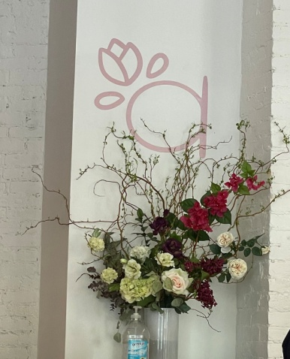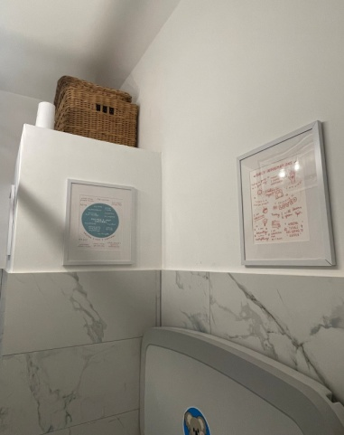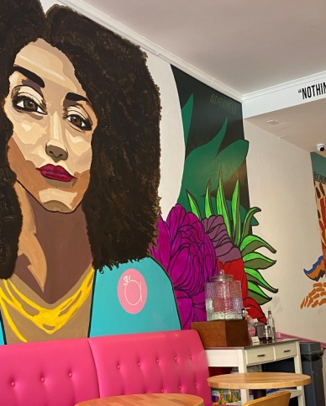
Interview #1
I see the woman who I spoke to earlier come towards me and sit by us.
“Hi how are you today,” I ask. “ good, how are you?” she replies.
I say I am good as well and then ask for her name which she says is Avril. She tells us how the store is named after her nickname which is Avrilillly. I then compliment her on how pretty her bakery is and how welcoming and nice they are. Avril was brought great joy from hearing this, thanking me. “ When did you open your bakery?” I ask. “ We have come in person for around three months now, we first opened on January 31 of this year.” This was a bit surprising considering how well decorated and organized this place looked, not to mention how talented they were. “ really? How has it been since then.” “Well not a lot of people know of us yet you know we are new but I think considering we have just opened up we are doing good,” she says. Since when we entered this bakery, there have been quite a few customers, which is great. Avril mentions that she has a lot of repeat customers who come bearing the gifts of friends. You can hear the smile she has under her pink mask as she speaks and her eyes squint as she smiles. She talks a little more about her customers being amazing. “Would you mind telling me a little about yourself?” I ask. Avril says “ yes, of course, I always knew that I wanted to open a restaurant but uh I actually have two master dresses, one on HR management and one on real estate.” She says she earned her master's in real estate in 2007 and her HR management master's degree last year,2021. This was pretty shocking and motivating to me because Avril looked pretty young. Avril continues to talk “ It’s kind of like coming together with both of my degrees, also my personal life experience in working at an investment banking for over twenty years, I also worked at the JP Morgan chase bank until last year.” Avril looks very passionate about talking about her past experiences. Avril worked at JP Morgan chase and made it all the way up to the executive director. “Oh wow, that's amazing and impressive,” I say nodding my head. “ So what made you want to open a bakery?” “ Um I wanted to take a bet on me, we always take chances on people why not do it to ourselves, this idea of wanting to open up my own place has been a small growing force within me, I’m a big fan of the grocery equity investment, and opening up my own bakery was always a dream you know we always take chances on people and I wanted to take a chance on me,” she says. I found Arvil courageous for doing this because this was something that many of us are not willing to do. For example, even if I myself was good at something I doubt I’d open my own store because of that.
Bringing joy to her customers other than just baked goods was the bigger goal for Arvil. Not only should the customer be here to try the food but to also feel welcomed and see this place as a bright welcoming place. This showed me how pure-hearted Avril truly is. Many places open their restaurant/store only for profit however, Avril put her customer’s happiness first. The place was well thought through. Growing up Arvil had a hard time accepting her hair, she would always straighten it to make herself fit into the word. Now she has embraced her hair as part of her identity and appreciates it very much which is why there is a painting of a woman with curly hair on the wall. Avril is big on women's rights which has its traits in the bakery. To support women Avril has a big pink hand sign which stands for women. She also has pads and tampons in the bathroom. The environment of the bakery was thought through so that both females and males find their bakery a very welcoming and accepting place. On the wall, there is a poem that mentions all of the names of the gelatos at the bakery. Avril says “ we discovered this poem in African American museum in DC.” “Oh, did you live in DC before?” I ask and she says no she and her husband were on a trip then. Through this Avril earned more respect from me. I have never witnessed a place to have such traits and it was amusing to see. I was very impressed.
“ Do you convey your feelings through baking?” to which she replies no.
Through my research, it was shown in great numbers that baking helped thousands feel more at ease but for Avril baking was not the cure.
“ Do you bake when you are feeling down?” I say to which again she says no. She says “ Baking brings a sense of satisfaction, if I bake when I am feeling down, my work won’t satisfy me, it would come out unpleasant.” That was an unexpected answer. Scoring to my research many have admitted that baking when feeling down was a way to cope with their emotions. With joy in her voice, Avril talks about her baking a little. “ So the flowers or any decor which I add to the cakes are completely eatable, nothing is not eatable” “ Oh wow I know a lot of people add like fake flowers and other items hats so amazing you’re so talented!” I say. “ Yes thank you, and now I am trying to make sugar flowers to put on the exterior of the gift boxes, I do everything from scratch, like in that cake over there I did the gum paste and everything, it’s like an outlet for me,” she says. I nod my head knowing how hard it must be doing everything from scratch. “ So what made you choose baking as a career?” I ask “ Well I worked in the financial industry for twenty plus years and now I wanted to open a bakery not only because it’s something I enjoy but also because it brings joy to others and my kids also started to ask for more elaborate cakes and so I started to play more with the colors and textures and I decided to open a bakery.” “ Oh wow that's amazing, it’s crazy how much more there is to the bakery than when you just take a look at it, that's all my questions, for now, thank you for your time today,” I say. She says your welcome and goes back to work.
End of interview
It’s so incredible how a place you may barely know of have so much history and meanings put into it. Avril put in so much time and effort in order to build the bakery she has now. In every corner of her bakery, you see items that hold great meaning. Places like Avril’s bakery bring a sensation of ease to us. We feel more comforted in being in a place that is very lovely than a place that looks hard to fit in. I learned a lot about the bakery and Avril herself.
Observation #2
I order an iced coffee and sit there for another two hours. I see children coming in and she welcomes them with a hyped “hi welcome.” They talk to you in a very friendly manner. Avril asks about everyone and takes their order. I notice there is an employee who’s also very kind, he was not present before. There is a man on his laptop who has been working on something ever since we came in here. The environment is very calming and welcoming. Everything is just in its place. After two hours of observing and pretty much rewatching the same things happen, I get up and leave for my lecture.

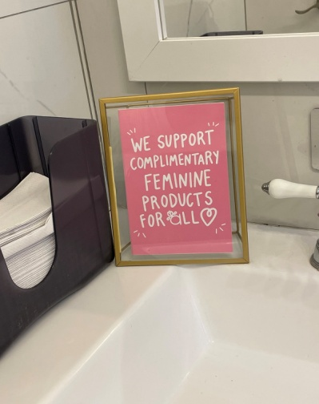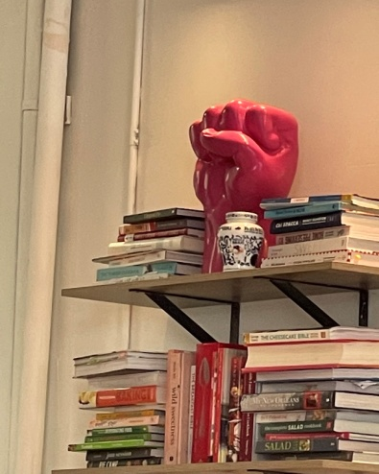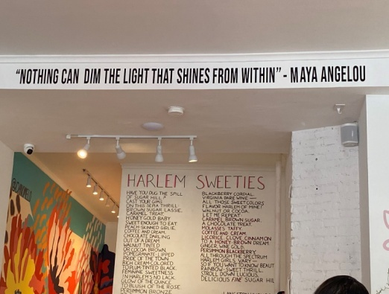
As I sit on the train I think about my second interview. It would be interesting if I did an interview with someone who has an online business instead of doing another bakery in person. So I went home and texted my cousin who has her own page on Instagram and sells a lot of baked goods. “Hey girly, would you mind doing a short interview with me for an ethnography that I was assigned?” She says “sure no problem.”

A few days later
It has been a few days and I am ready to do my second interview. My cousin's name is Nadia. Her account on Instagram and other social media platforms is sweetsbyxnadia. Nadia is a very hardworking individual who puts in her precious time and effort to make sure she is doing her best at serving her customers.
Interview #2
“Hey girly, are you ready to do the interview?” I text her. “ Yes how are we doing this interview, via facetime right?” she asks me and I say yes. I then proceed to ask her my questions. “Do you enjoy baking?” “Yes, I do.” She says. “What made you start your page?” I ask her. “Baking has always been a favorite hobby of mine since I was a child. I began baking small dishes for various occasions for my family. Eventually my friends and family encouraged me to start my own business, which I did. It's been going great for me, and I'm really enjoying it.” Nadia says while smiling. I recall when she texted in our cousin's group chat bringing up this topic to which all of us encouraged her to open up. Nadia mentions that it has been a year and a half since she opened her baking page. “How long have you been practicing baking?” “Since I was pretty young,” Nadia says.
I can see on the facetime call that she is enlightened when speaking about this topic.
I ask Nadia how she thinks it would be different if she were to be doing it in person and not online. Nadia says it would have been much different if she had her own store if it was in person rather than online. Nadia says she would have a lot more space in a store than she has at home. Nadia also mentions that she prefers working from home. She gets to choose what she wants to bake and create for personalized orders for consumers from home. It would take a lot of time and effort to have a bakery. It was enlightening to learn so much more than I knew about her thoughts on her business. “Have you made a great profit since then?” I ask. Because we are related I felt comfortable asking her personal questions. Nadia did not seem to mind me randomly asking her a bunch of questions. “Yes, I have made a great profit since I have started my business,” she says. “Do you convey your feelings thru baking?” In between, I hear a lot of noise in the back and she tells me it's her siblings. I hear them speaking about the bridal shower for her sister who’s going to get married over the summer. “Making treats helps me to express myself via food in a unique way! Because these lovely treats take so much time and work to prepare, bake, and decorate, they're more than simply sugar and spice. Decorating cookies with colorful icing swirls and twirls will help me express whatever is going on in my mind. Furthermore, the flavors I select will convey the moods I am experiencing at the time. I choose to add the delicious yellow sprinkles when I’m happy. Making my own baked goods look intriguing and taste delicious lifts my spirits when I’m sad. Baking conveys my feelings through the mix match of colors and scenes in the same way that painting does.” Thinking back according to the journal of positive psychology, it was said that baking can be a stress-relieving strategy. It is seen that this applies to Nadia here.
“ I need you to teach me baking, I can’t do that to save a life,” I say amazed to see how much baking has an impact on her.
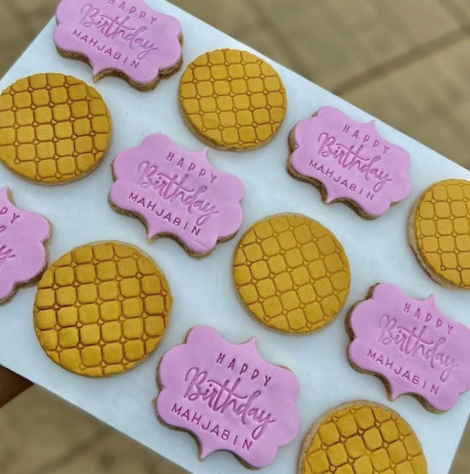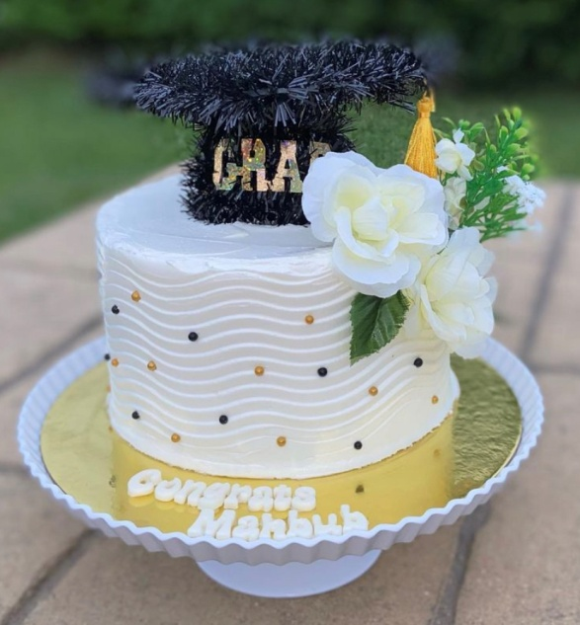
Nadia speaks a little more about the impact baking has on her. She says baking drastically impacts her mood. Baking is very therapeutic for her. When she is feeling down Nadia bakes. When Nadia is in sorrow she tends to bake goods in dark colors such as black and blue. When she is happy she uses bright colors such as yellow as she mentioned before. Baking is something she enjoys doing and it’s a source of relaxation. I then ask her my last question, “Do you think you have a chance of opening your bakery in the future?” I ask. “Yes, I believe I will be able to open my own bakery in the future. I am very excited for that moment to come” she says. She has a happy smile on her face and genuinely has an excited facial expression. “ Ooo that's exciting I didn't know that,” I say. She laughs and we end our call.
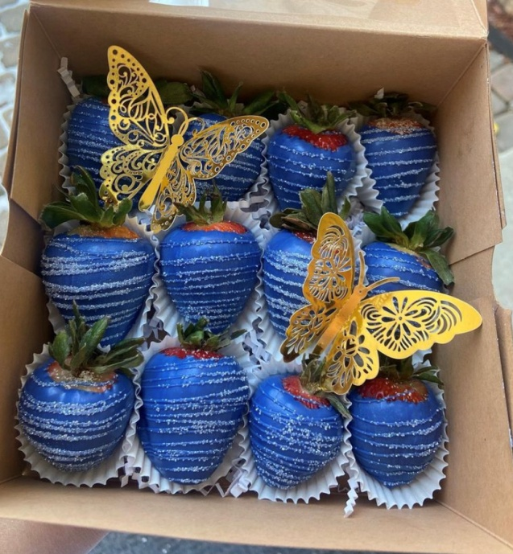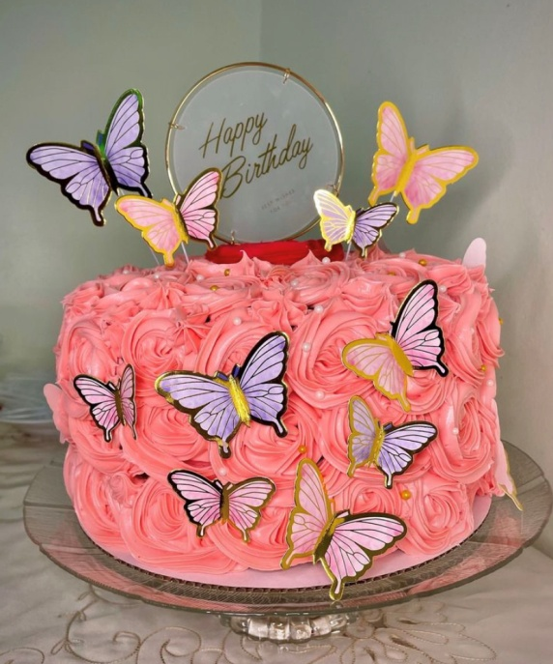
End of interview
It felt like although I knew my own cousin I did not know her. When speaking about a subject you are passionate about it can change your whole expression and mood. By the end of the call, Nadia looked like she was emotionally in a better place. It looked as though talking about baking, which she loved and enjoyed brightened her mood. Baking is also something I am very interested in however, I can’t bake. Both Avril and Nadia are very passionate about baking. Baking has great meaning in their lives. Baking has bought lots of joy along with hard work to them.
As my interviews came to an end I learned so much about things I didn't know much about. These two interviews brought back memories. I baked a cake once, it didn’t look pretty but it did taste good. Baking, according to philosophy, is a method of stress relief and relaxation. It aids in relaxation and unwinding. It stimulates your appetite. It's also a way to bring your imagination into reality by being creative and having control of your ingredients to bake goods. Avril was not able to relate to this which was surprising however Nadia was able to relate to this. The two interviews I did went well.

